**Net3006A Network Management and Measurements** (Winter 2025)

Instructor: Jie Gao

Assignment 3 (Lectures 9 – 12) **–** Due at 11:59pm, Monday Mar 31, 2025 Please submit **a single PDF file** to “Assignment 3” on Brightspace

**Q1.** [0.9 Points] Answer the following questions in one or two sentences.

# Grading Rubric:

0.3 point for each sub-question.

1. In RMON, what mechanism is used to mark the entity that configures a table entry and help relieve potential conflicts among multiple managers?

Ownership Label

1. On slide page 16 of Lecture 9, we introduced something called “row status”, which is closely connected (i.e., essentially sharing the same idea) to something else we introduced in Lecture 12. Can you tell what from Lecture 12 is closely connected with “row status”?
2. Which layer in the TMN hierarchy concerns end-to-end connectivity?

**Q2.** [1.2 Points] Answer True or False for each of the statements below and briefly explain why in one or two sentences.

# Grading Rubric:

0.3 point for each sub-question.

* Answer (True/False) correct, explanation (mostly) correct: 80-100%
* Answer correct, explanation (at least partially) correct: 60-80%
* Answer correct, no explanation or explanation irrelevant/incorrect: 50-60%
* Answer incorrect, explanation relevant and (at least partially) correct: 0-50%
* Answer incorrect, no explanation or explanation irrelevant/incorrect: 0%

1. In the response to an SNMP set request, the values in the variable bindings are set to null.

False

1. A flow means the data traffic between a pair of source host and destination host.
2. Having a management hierarchy is sufficient to guarantee scalable network management.
3. An RMON probe does not only collect, store, or filter data but may also process or analyze some data.

**Q3.** [1 Point] A MIB Table at an agent is given below. Answer the following questions:

1. [0.2 Points] If a get-next request with input OID 1.3.6.1.2.1.4.20.1.2.9.196.8.138 is sent to the agent, what will be the variable binding carried over the response message? Note: give the variable binding in the format of <OID, Value>.
2. [0.3 Points] If a get-next request with input OID 1.3.6.1.2.1.4.20.0 is sent to the agent, what will be the variable binding carried over the response message? Note: give the variable binding in the format of <OID, Value>.
3. [0.2 Points] If a manager wants to retrieve the entire second row (starting with 123.45.3.4) using one get-next request, which OID(s) should be used in this get-next request?
4. [0.3 Points] Is the combination of input OIDs that can achieve Q3.c unique? If yes, explain why. If not, specify the valid range of each input OID in the get-next request that can achieve Q3.c.

1.3.6.1.2.1.4.20.1

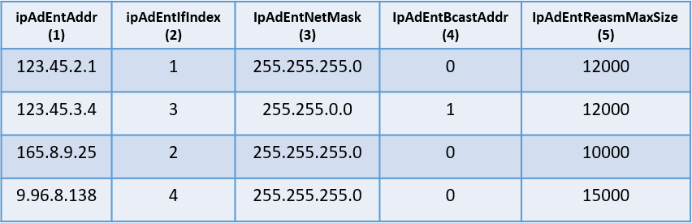

ipAddrEntry

The index column

Figure 1: Figure for Q3

# Grading Rubric:

* For Q3.a and Q3.b, the correct OID and the correct value weigh 50% each
* For Q3.c and Q3.d, only the OIDs are needed.

**Q4.** [0.9 Points] A MIB at an agent is given below. Answer the following questions:

1. [0.3 Points] A manager only wants to retrieve the value of the “sysName” instance from this agent. However, for some reason, it must use a get-bulk request to retrieve this one object. Give the get-bulk request message that it can use (Note: see the request message format in Q4.b below).
2. [0.3 Points] Is there only one way to use the get-bulk request to achieve Q4.a? If yes, explain why. If not, give a second way to use the get-bulk request to achieve Q4.a. Note that the difference in your answers to Q4.b and Q4.a should be more than just different input OIDs.
3. [0.3 Points] A manager sends the following get-bulk request to the agent GetBulkRequest(1, 3, 1.3.6.1.2.1.1.5.0, 1.3.6.1.2.1.2.2.1.10.5)

Give the response to this request. Note that you can use “<value>” to replace the actual values in the variable bindings since the actual values are not given.

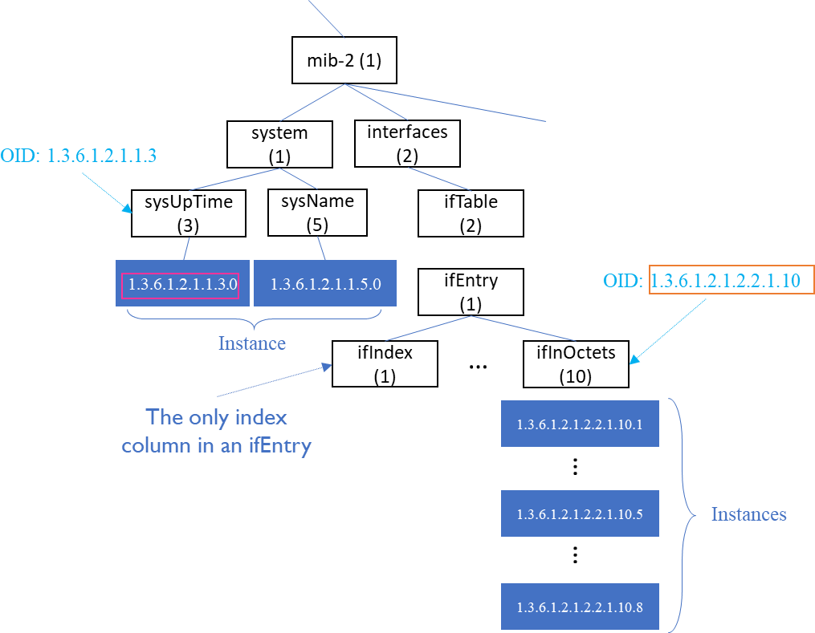

# Grading Rubric:

* For Q4.a and Q4.b, the 0.2 points are evenly distributed over all fields in the request message.
* For Q4.c, the 0.2 points are evenly distributed over all fields in the response message.